**Figure 1a. West Nile Virus Surveillance Vector Index for all *Culex* by zone (2006-2017).**

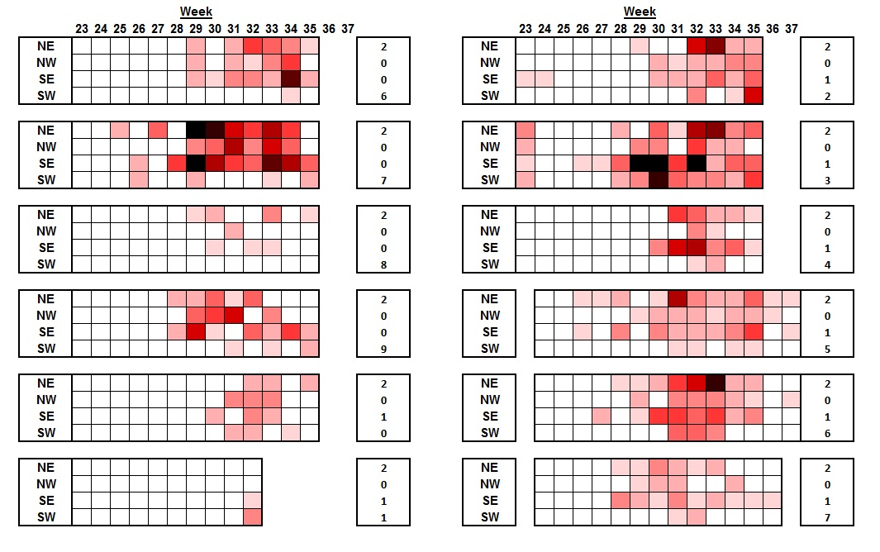



**Figure 1b. 2017 WNV surveillance City Wide Vector Index in relation to (2006-2016) Historical Averages.**

